CHAPTER 7 THE CHILDREN of Lorane Joyce Eaton and Daniel Quentin Boje
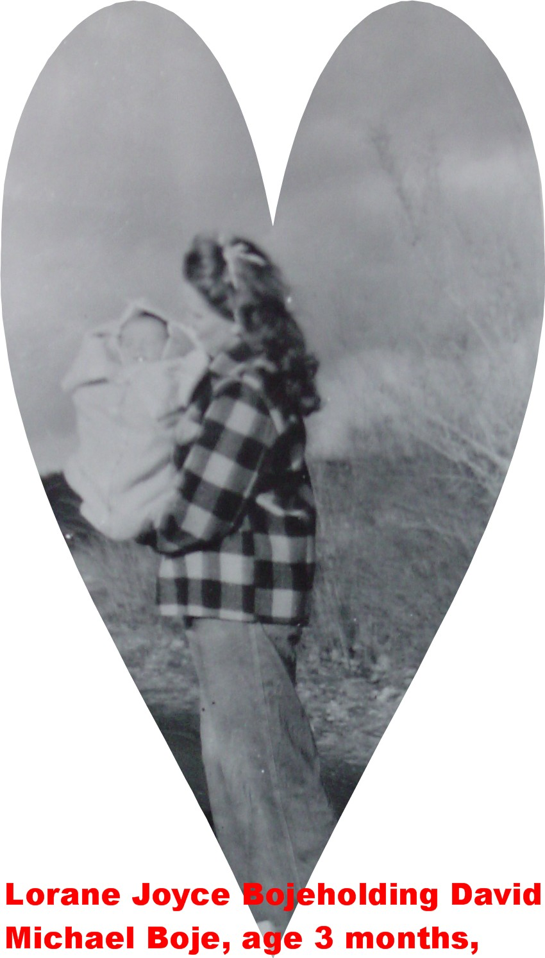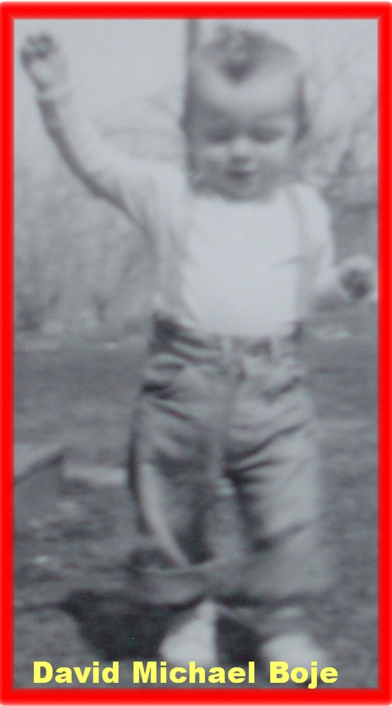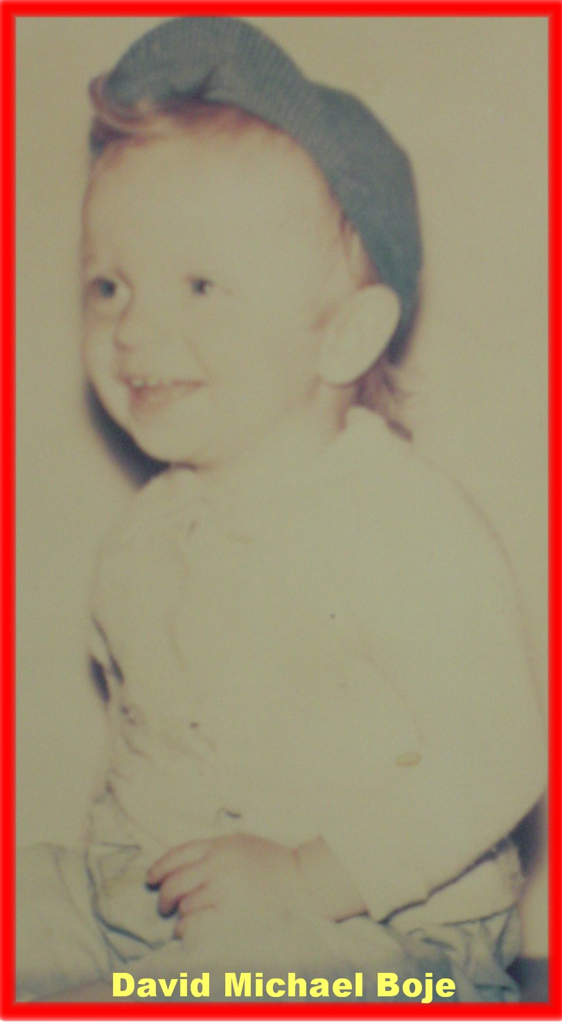

David Michael Boje born Dec 17 1947 Spokane WN
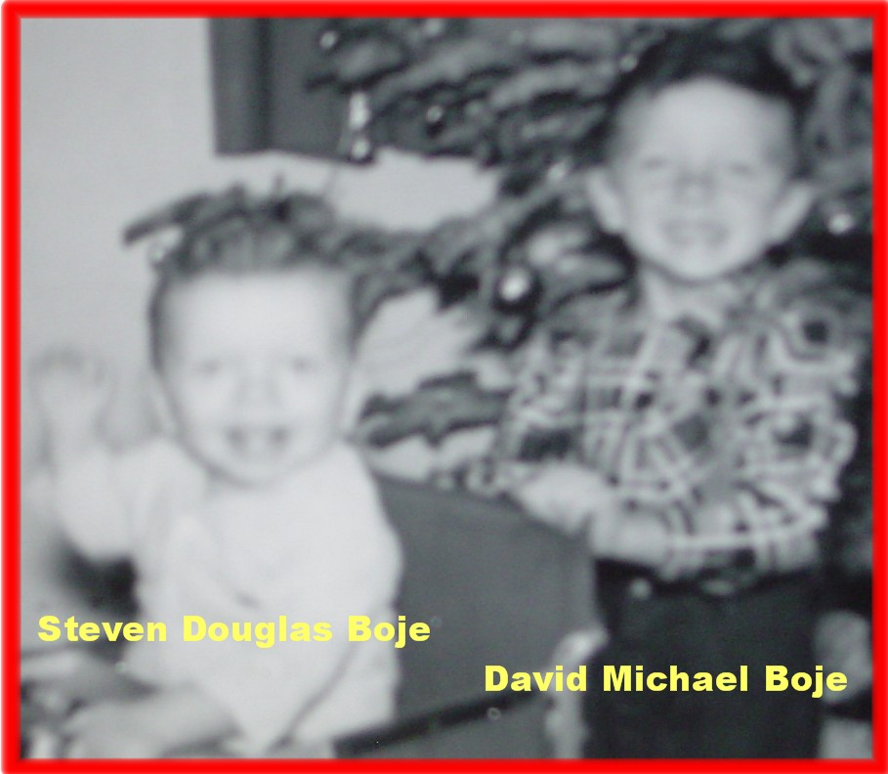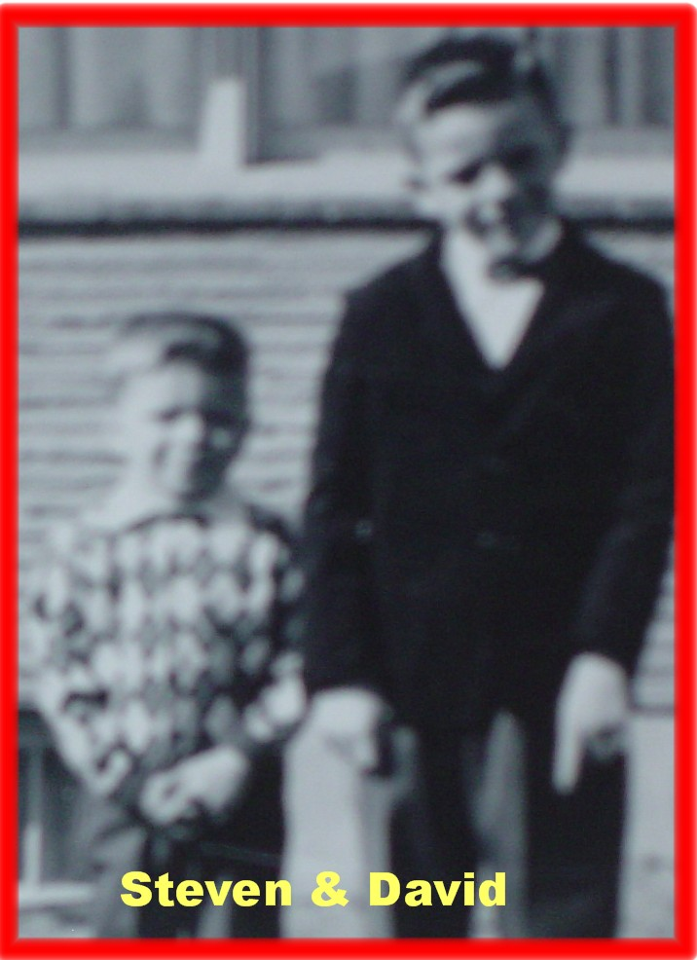
Steven Douglas Boje born Jan 14 1952 Pasco, WN
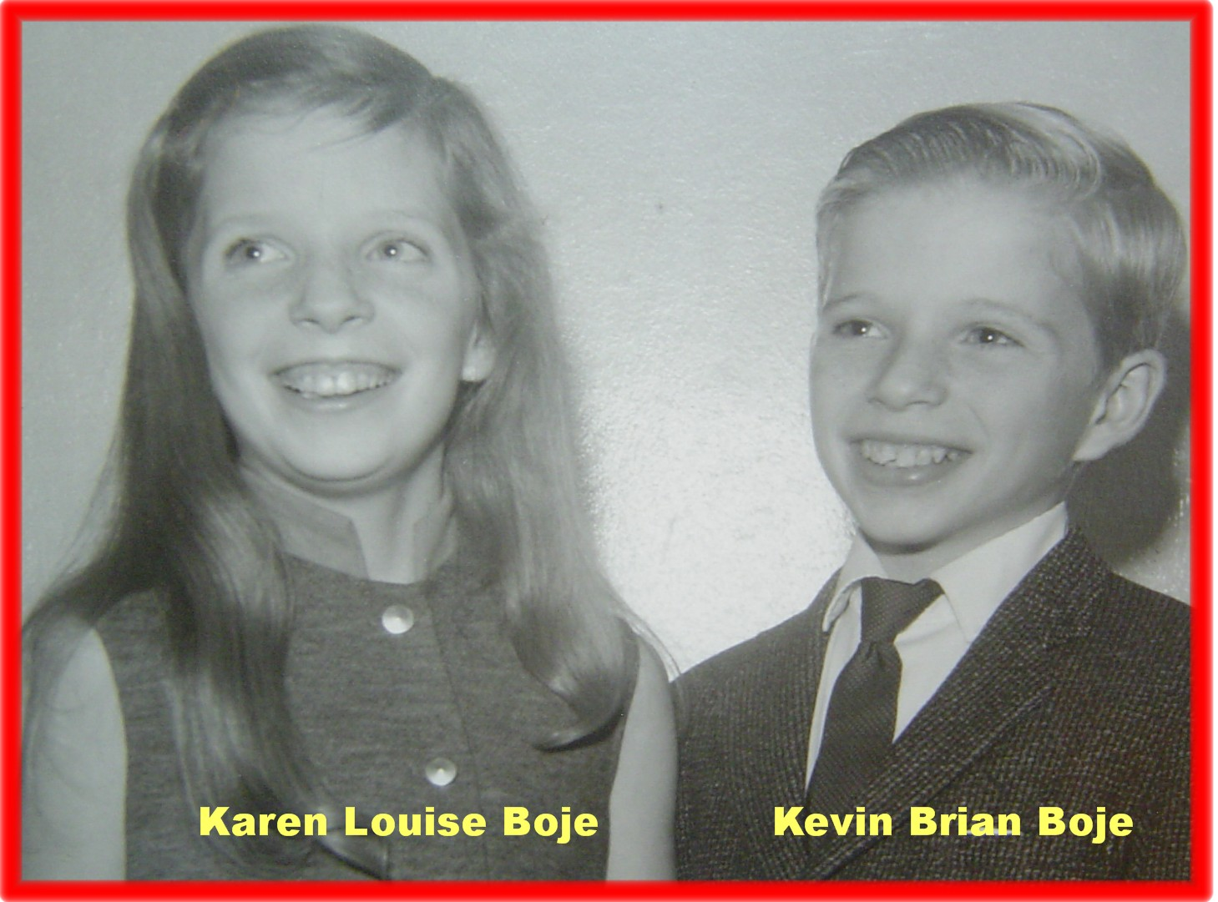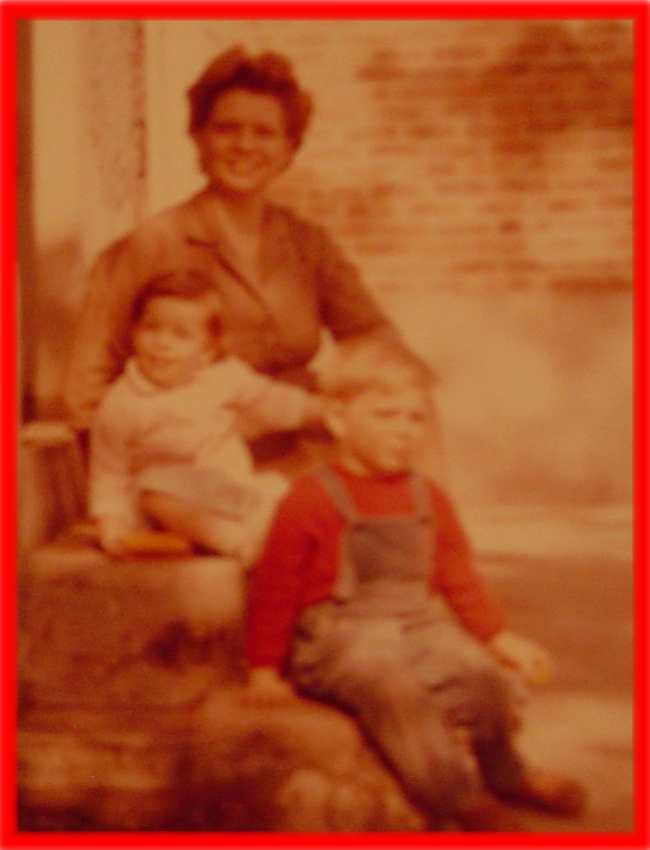
Kevin Brian Boje born Apr 2, 1958 Anchorage Alaska
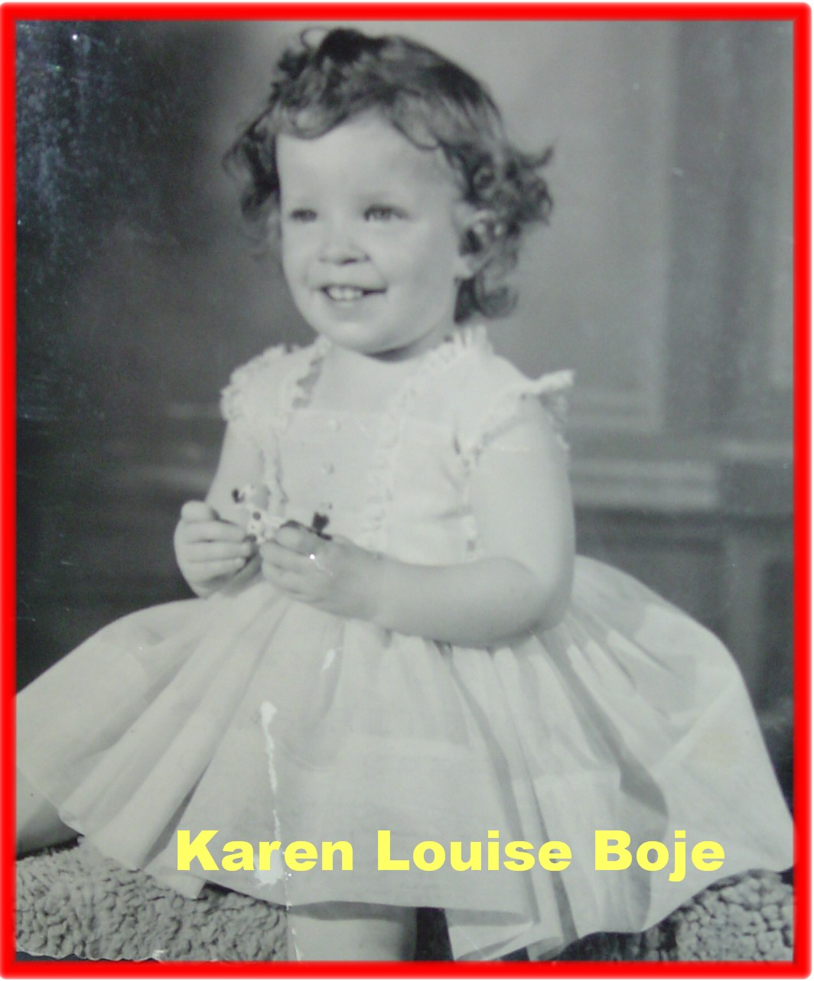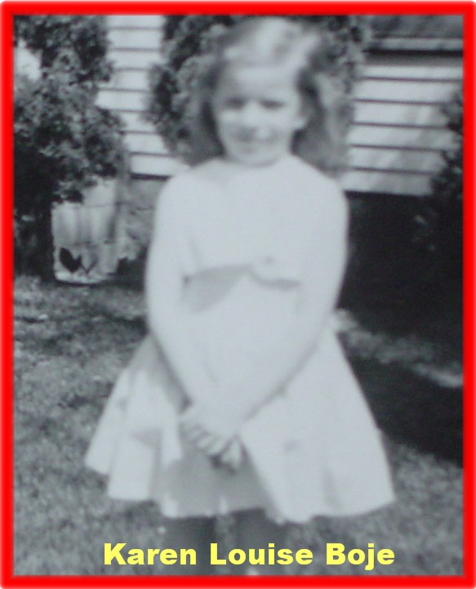
Karen Louise Boje born Sep 10 1959 Anchorage Alaska


